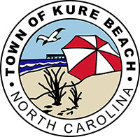

TOWN OF KURE BEACH 2022 PARKING FEES

- Hourly Rate: $5.00
- Daily Rate: $20.00
- Weekly Rate: $100.00
- Resident/Property Owner Seasonal Permit: $20.00 (Limit 2)
- Resident/Property Owner Seasonal Permit (if purchasing more than 2): $100.00
- Business Owner Seasonal Permit: $20.00 (Limit 2)
- Business Owner Seasonal Permit (if purchasing more than 2): $100.00
- Local Business Employees Seasonal Permit: $75.00
- Non-Resident Seasonal Permit: $200.00
- Marked Handicap spaces are free parking with Handicap Placard or license plate
- Purple Heart Recipients with a Purple Heart license plate may park for free in any marked space
- Church parking on Sunday from 8:00 am to 1:00 pm is free at the following locations:
  - 3rd Avenue, between K Avenue and L Avenue
  - 6th Avenue between I Avenue and J Avenue
  - KB Community Center Parking Lot (118 N 3rd Avenue)

