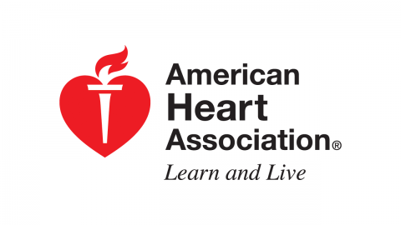

**WHAT:** Adult CPR, AED, and First Aid Certification Course

**WHEN:** Saturday, March 7, 2020

9:00am – 3:00pm; please bring your lunch/snacks

**WHERE:** Kure Beach Community Center

118 N. 3rd Avenue, behind Big Daddy’s Restaurant

**WHY:** You can earn an AHA Certification in each of the 3 – Adult CPR, AED, and First Aid.

**WHO:** The class will be taught by Kure Beach’s State Fire Instructor, Jim Dugan, who has over 30 years teaching experience.

**HOW:** Sign up at Kure Beach Town Hall. The cost is $50 per person. Class size is limited to the first 12 people.

C:\Users\parks\AppData\Local\Microsoft\Windows\Temporary Internet Files\Content.IE5\L49EL57S\MC900347925[1].wmf